**Sumita Jain**

**Matplotlib Homework: Pymaceuticals**

The graphs below summarize outcomes of the squamous cell carcinoma clinical trials. During these trials, 250 mice subjects were treated through four drug regimens over the course of 45 days.

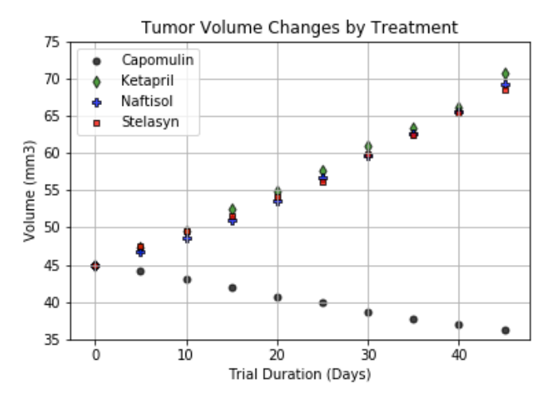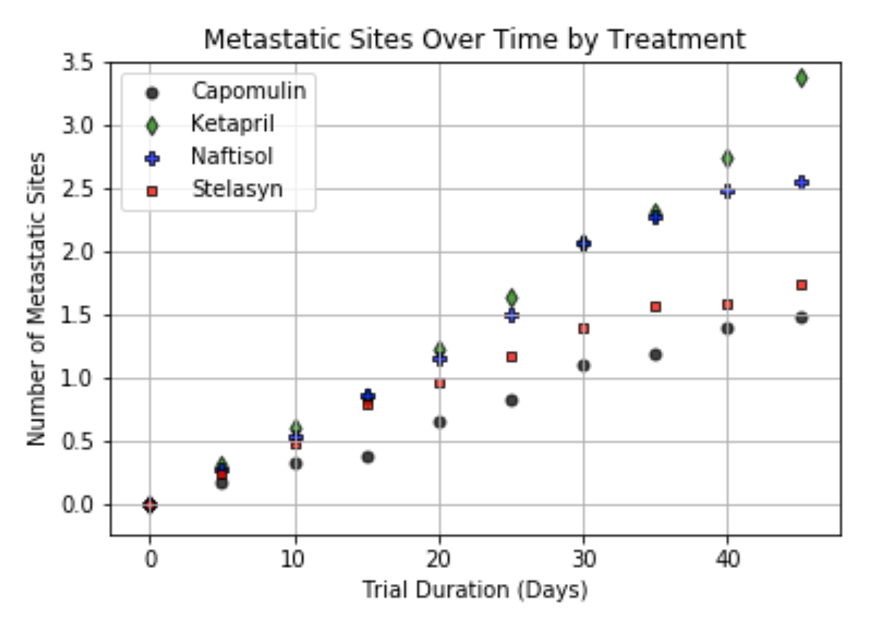

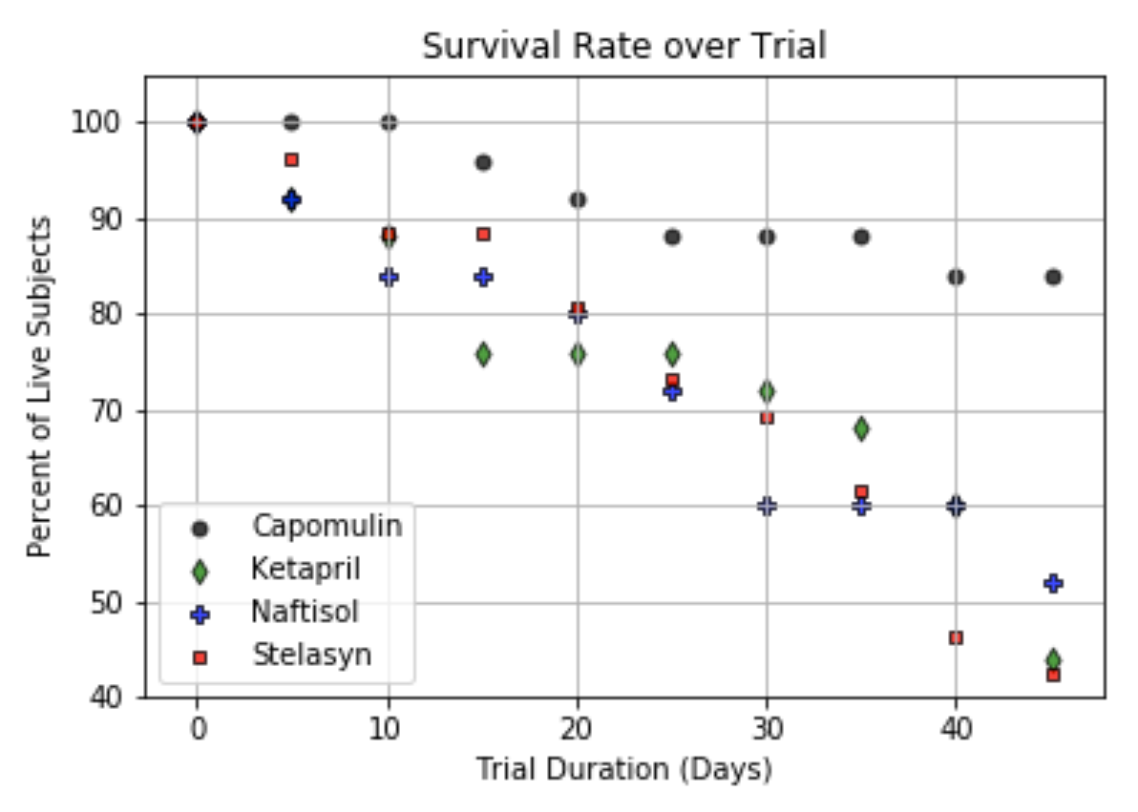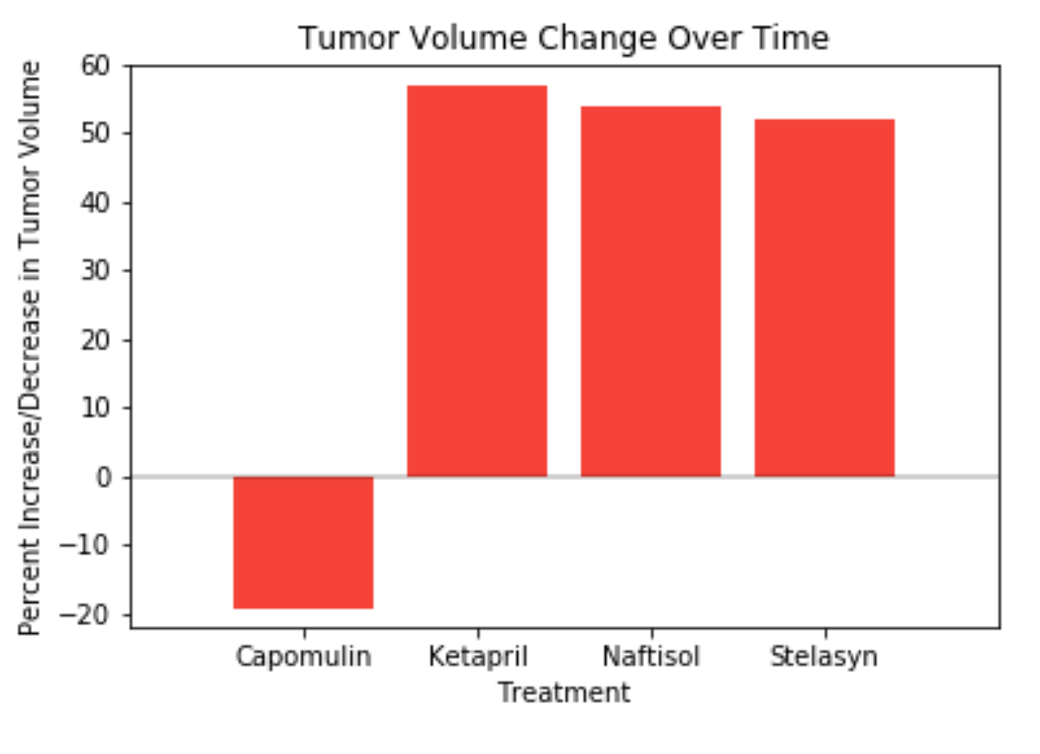

From the graphs above, assuming that all other conditions remain constant, one can conclude that Capomulin is the most productive of the treatments.

1. Capomulin was the only drug regimen that led to reduction in tumor volumes over the period of treatment. Tumors treated with the other three drugs continued to grow by an average of approximately 50% over the course of the 45-day trial.
2. The Capomulin drug regimen also yielded the best survival rate for the subjects of the trial. More than 80% of the subjects treated with Capomulin survived the 45-day trial. The next closest drug regimen was Naftisol – only about 50% of those subjects survived the trial.
3. While the distinction is not as dramatic as in the case of tumor volume and survival rates, Capomulin treatments also led to the lowest metastasis. Stelasyn was a relatively close second in addressing the spread of cancer.